## Statsig

Scoping start date: Apr 3, 2024

Implementation Completed Date (Go live date): May 10, 2024

MSA Signature Date: Apr 30, 2024

GTM POC: Skoro

ERP: QBO

Tax Integration: Other Anrok via QBO

### 

### Key people at Merchant

### Lauren Burke <[lauren@statsig.com](mailto:lauren@statsig.com)> Head of Revenue Ops

* + Very interested in our key terms tracking functionality

### Stephen Praast <[stephen@statsig.com](mailto:stephen@statsig.com)> Head of Finance

* + Signatory and keen on invoicing

### Company summary

“Thousands of companies, from startups to Fortune 500s, rely on Statsig: the single platform to ship, test, and analyze new features”  
  
AM Notes

See [deck](https://docs.google.com/presentation/d/1VT8j0XUPSvQu7MAf6VBlp6_GOnZHIdgJhBza0nfWmOw/edit#slide=id.g2c88f679b37_0_41) we used to close the deal.

“What we heard about Statsig…”

* Pricing model evolution has limited the ability to automate as the contract structure, billing terms and metrics have changed over time → mix of structures that require support today and in the future with legacy and future models at play
* Lack of visibility into current repository of contracts → difficult to pattern-match across agreements or understand exposure and opportunities
* Usage based billing appears in 95% of customer contracts but is not uniformly enforced → no visibility into potential lost revenue or mechanism to capture this in the future
* Manual invoicing with no ability to schedule in advance → time-intensive process to manually send each invoice each period
* Spreadsheet inputs as the primary mechanism for AR → key person and human error risk
* Reports get spun up from scratch → time and effort to recreate reporting on an ongoing basis
* Manual follow-up dunning emails → significant aging / high DSO challenges

“Where Tabs can Support…”

* Contracts: create a home for contract key terms and billing details, automatically re-generating based on amendments & changes to customer relationship with easy filters
* Usage / Variable Billing: upload usage data to either trigger overages, and/or create visibility into what is being waived. Empower the business to quantify the implications of not charging for variable terms.
* Automated invoicing: full integration to automatically create future invoices and reconcile in your existing ERP (QBO today)
* Collections: set dunning sequences and customized escalations; inter-team collaboration
* Reports: AR & Collections reporting, revenue reporting released in April/May

### Billing model

* Mostly annual, some quarterly and monthly
* Fixed price for the period, billed up front
* There is a quantity of events that are contracted but these are not tracked carefully and any overage incurred is not billed

### Contract Processing Steps

1. There’s a one page order form associated with all contracts (or at least all future contracts). That form has a statsig logo and has everything we need to know. can skip other stuff in the overall PDF.
2. **Do not create any BTs for overages. All usage-based terms can be skipped. Billable Events Line Items are written as Flat Price BTs (not in arrears).**
3. **Billing starts at the start of the subscription term**; don’t worry about signature date or any other dates.
4. For now, leave integration items blank or assign to Sales. In the future, Stephen will provide us with guidance on what integration items to use.
5. If customer does not exist in QBO already, please create the customer.
6. Leave all quantities as 1 and instead put the quantity of events in the description field. This is essential because QBO cannot support a quantity over 100b. See attached screenshot for explanation:

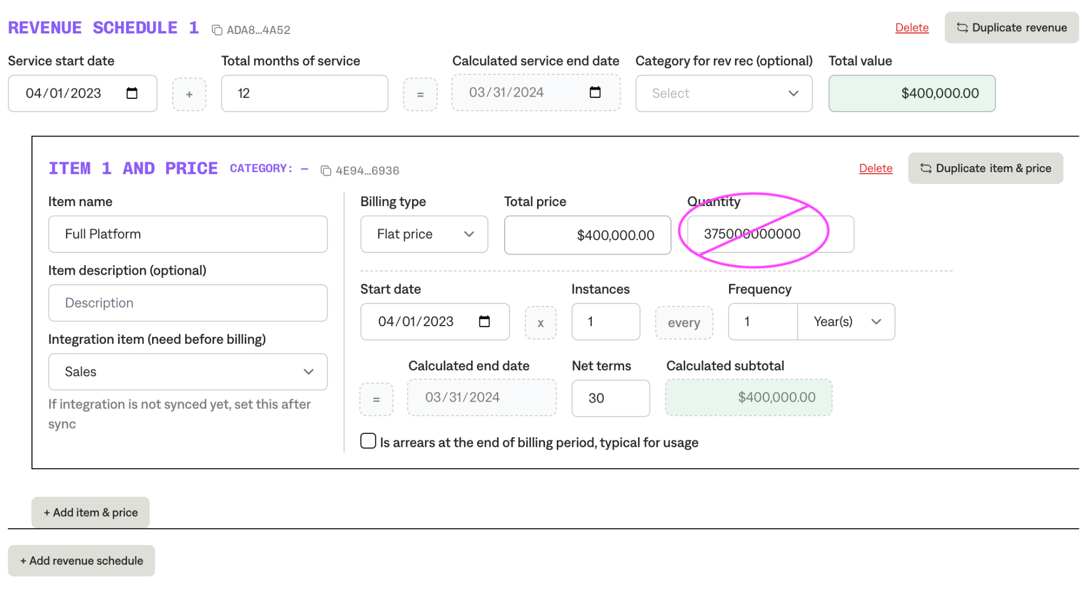

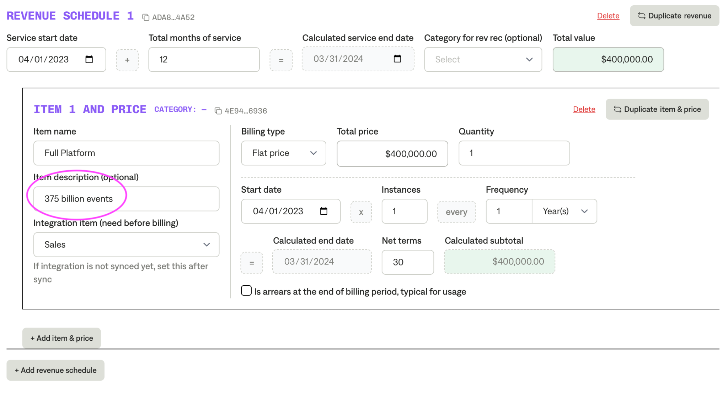

### Events Processing (if necessary)

* N/A

### Customer Information

* N/A

### Feature Requests

* N/A

### Rewatch Calls

* Onboarding v1 – <https://tabs.rewatch.com/video/x8cplq61by5559wv-stephen-praast-and-matthew-skoro-may-9-2024>